**Task - 13**

**Creating a EC2 in zone 1a:**

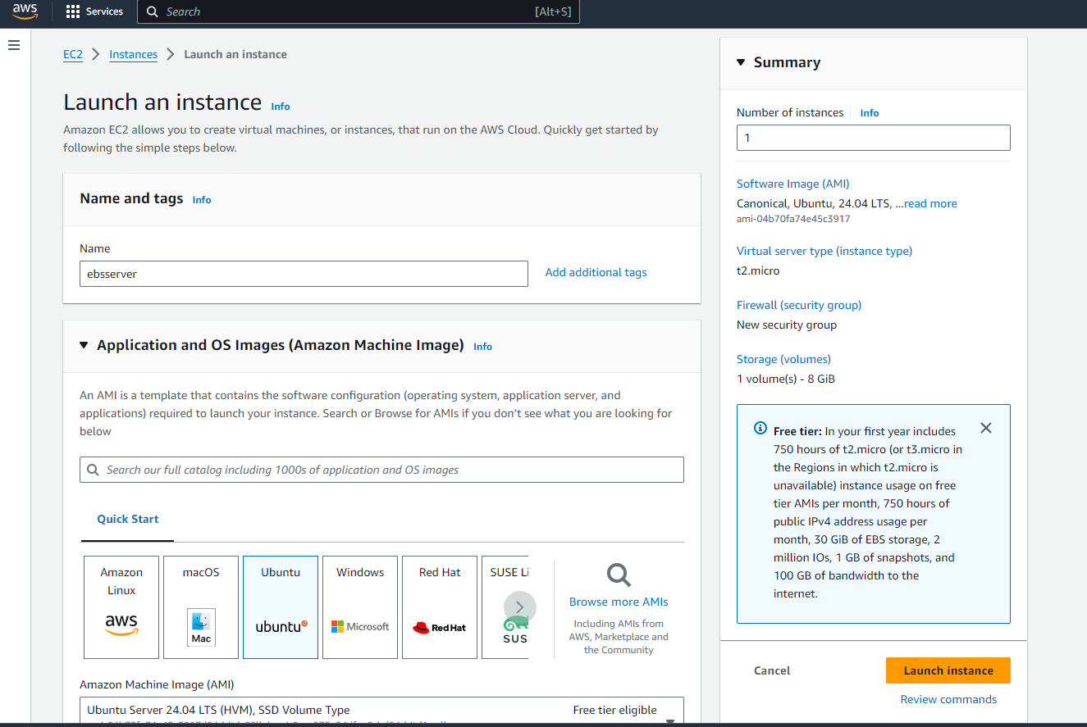

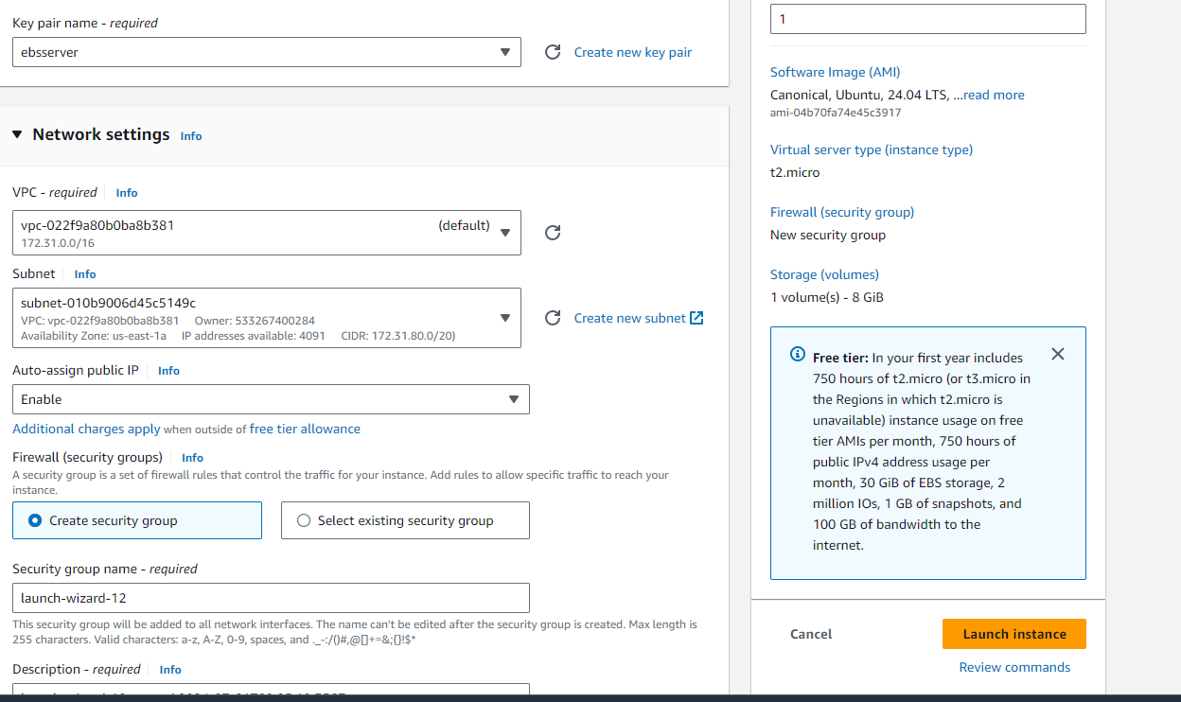

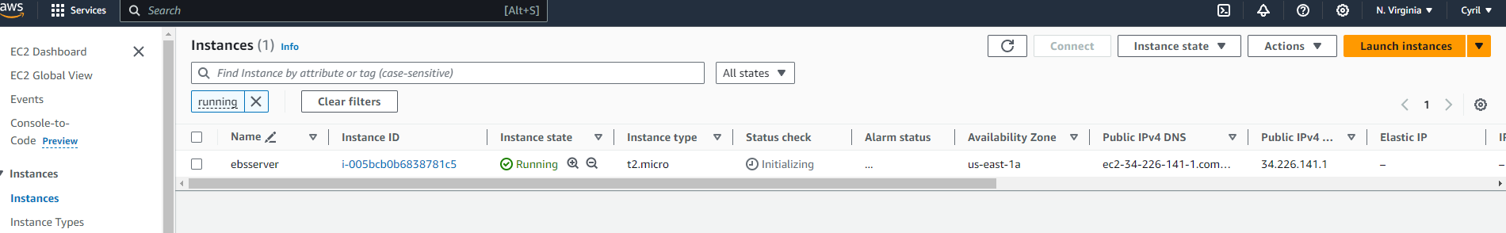

**Creating a EBS volume:**

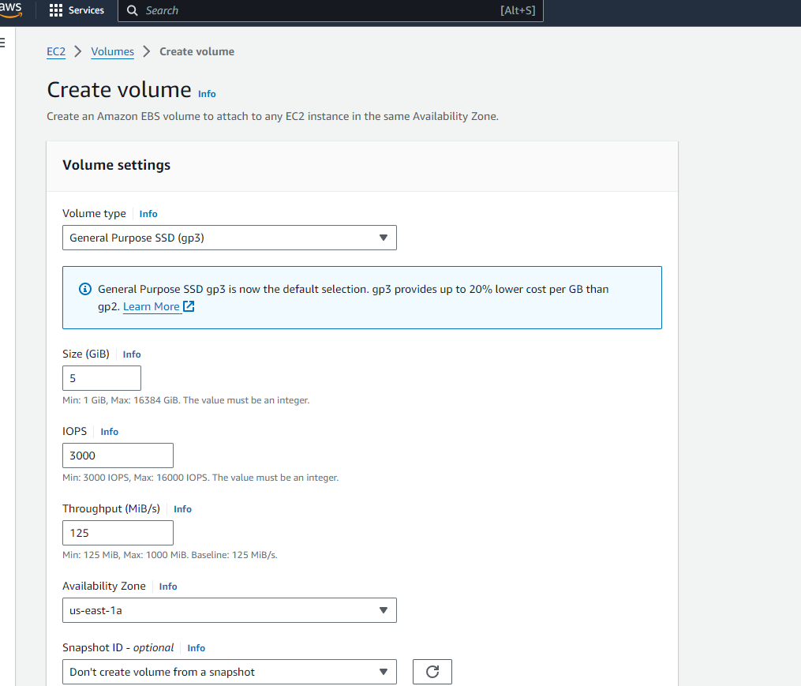

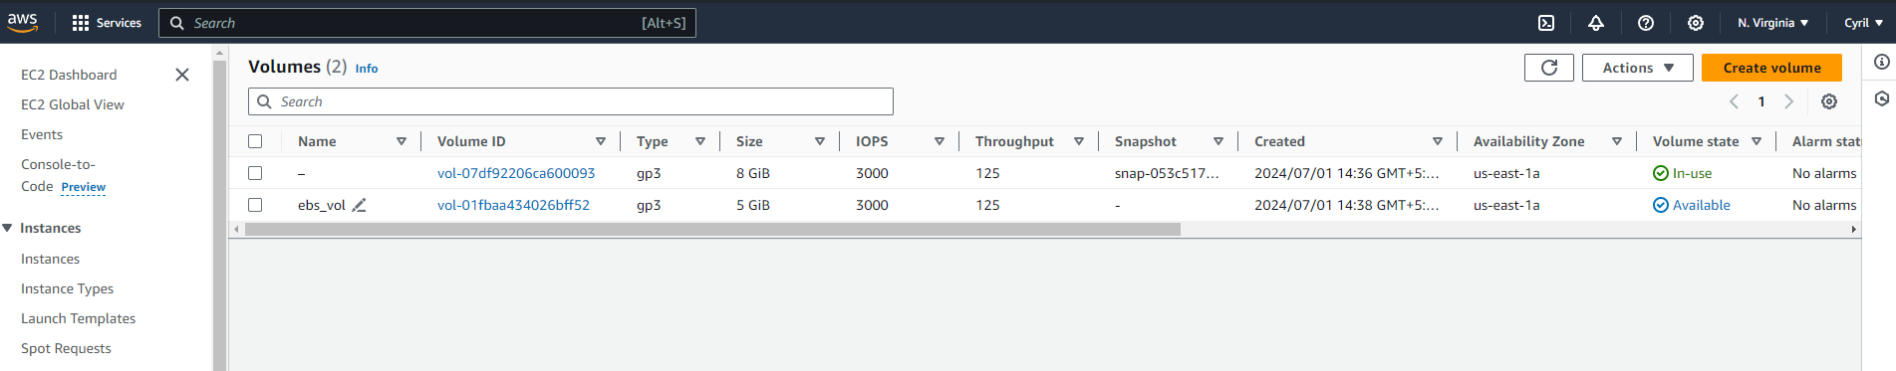

**Attaching the EBS to EC2 machine:**

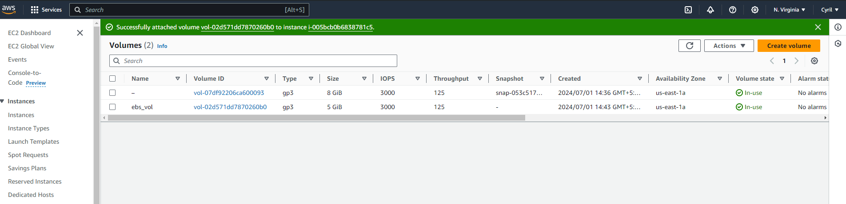

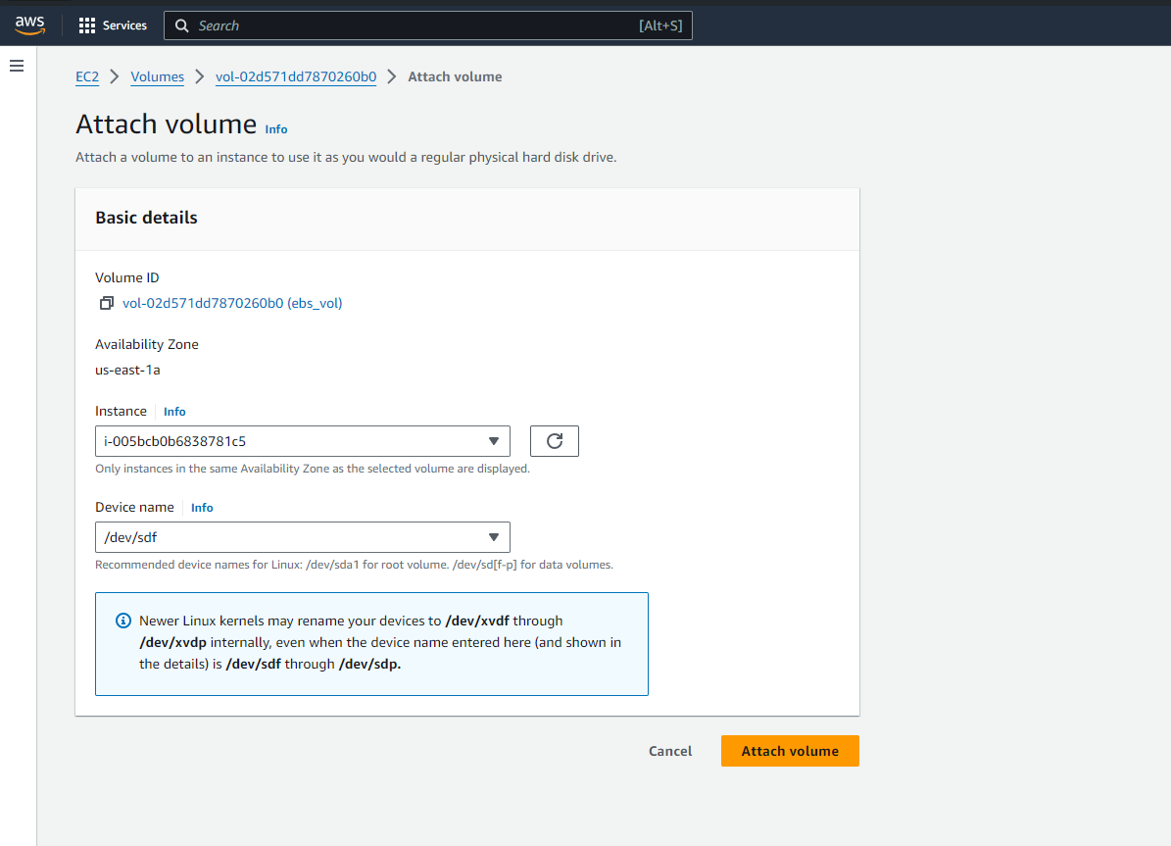



**Installing a webserver in EC2:**

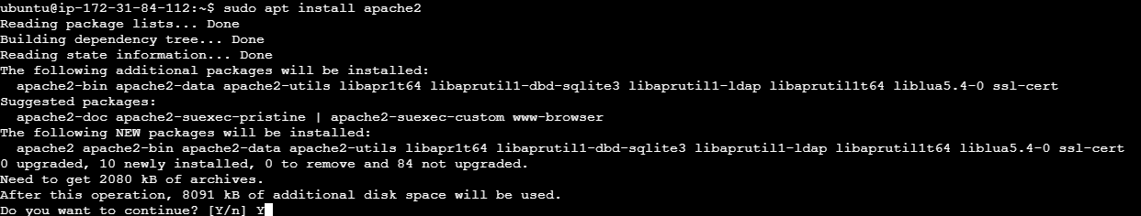

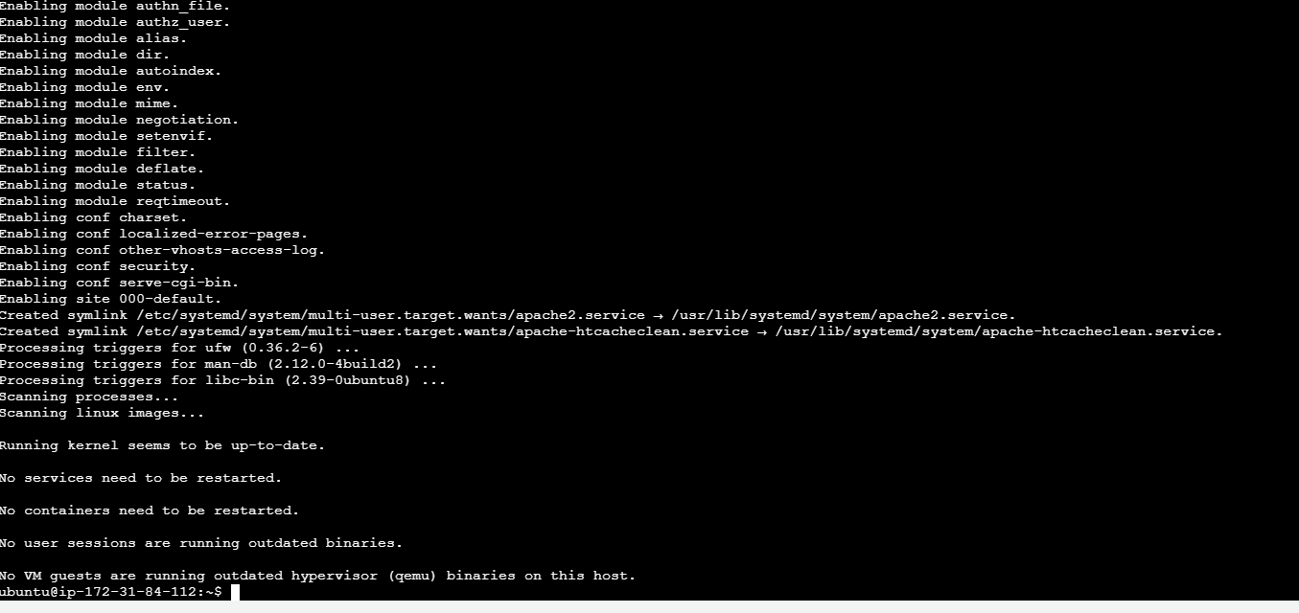

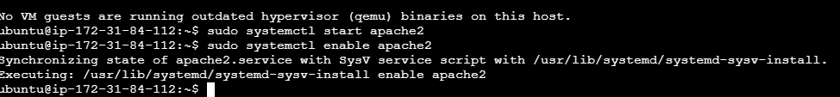

**Formatting the EBS volume in EC2 machine:**

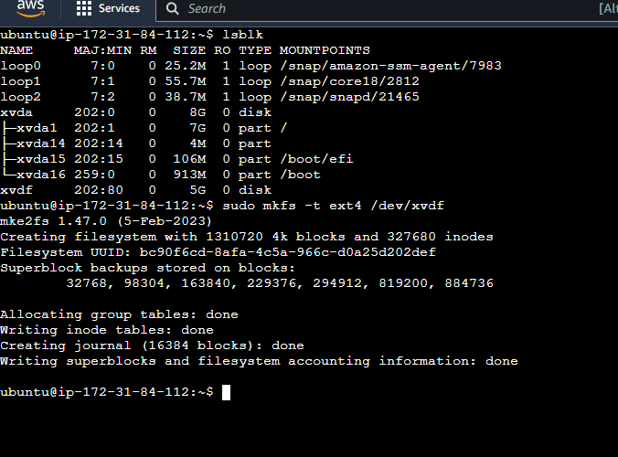

**Mounting the EBS volume to the EC2 machine:**

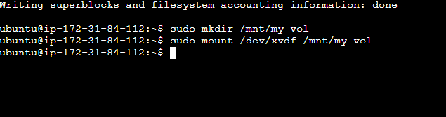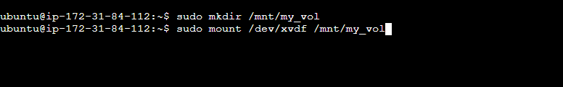



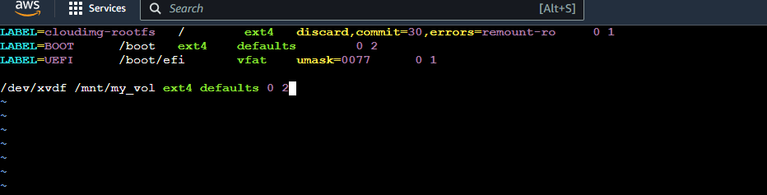

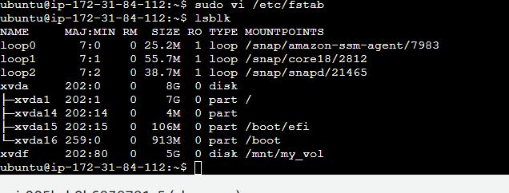

**Taking snapshot of the created EBS volume:**

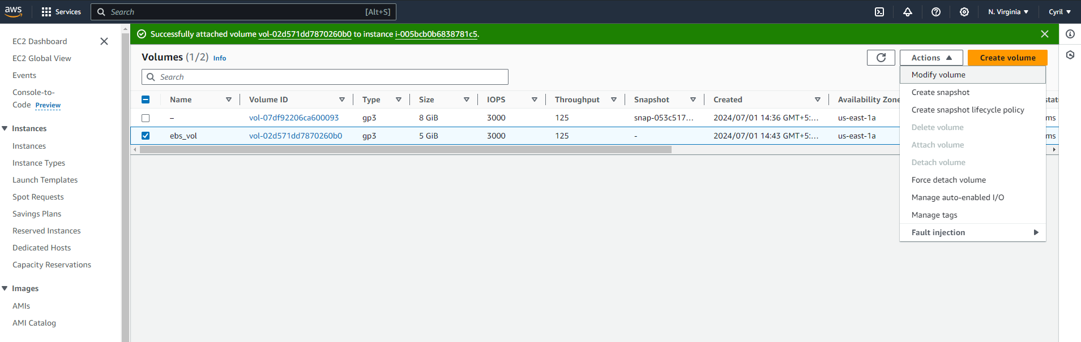

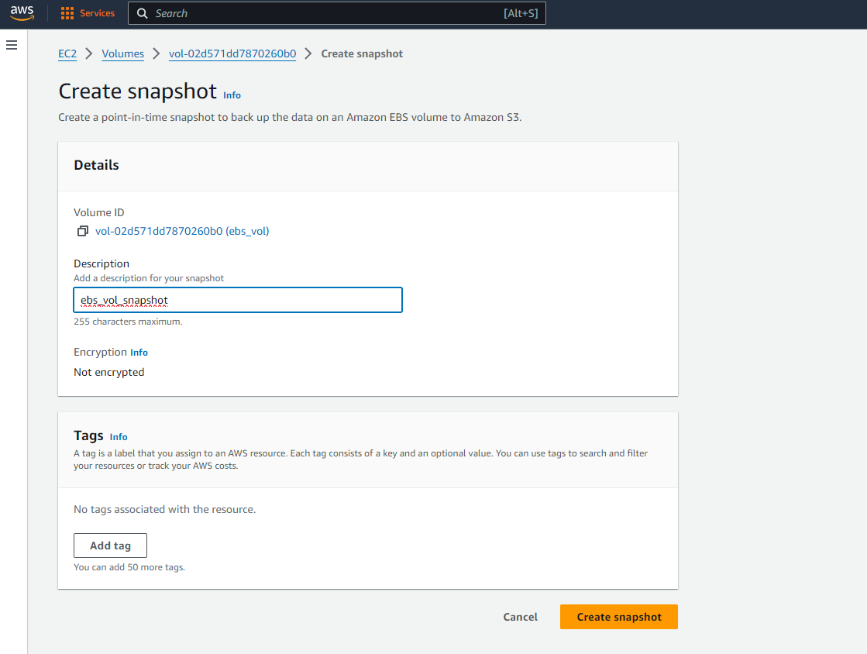

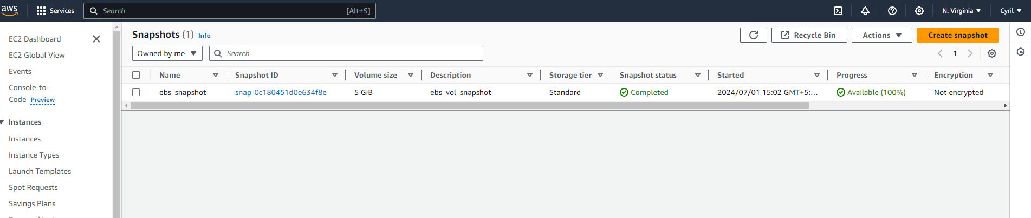

**Creating a EBS volume using the snapshot:**

